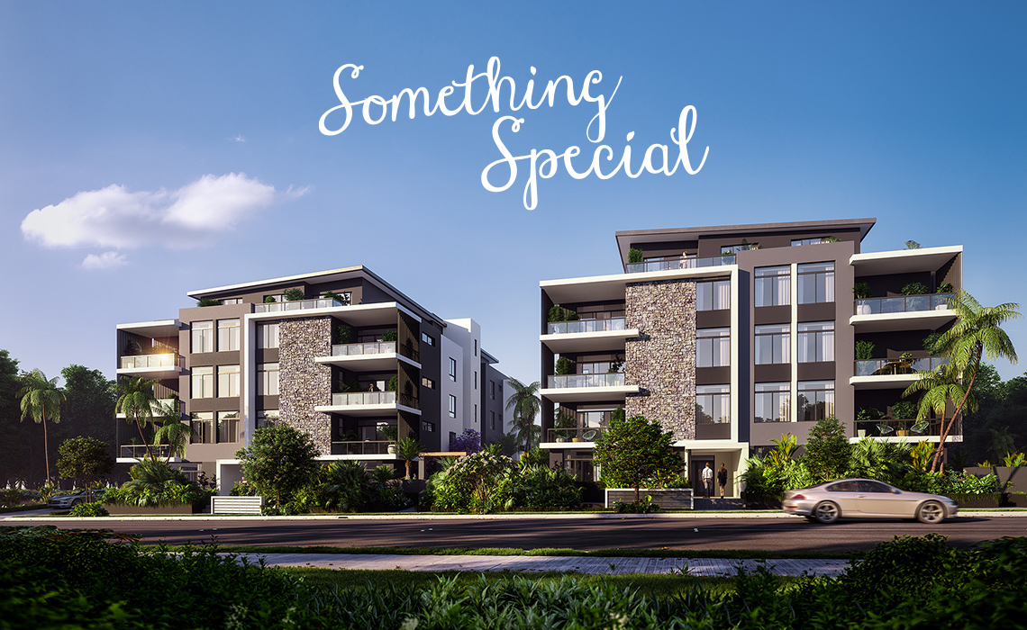

DISCOVER YOUR DREAM HOME

This ideal family environment provides residents access to their very own private Oasis. Enjoy private courtyards, peaceful communal garden spaces and shared family entertainment areas,complete with children’s playground equipment, an outdoor gym, barbecue areas and a picnic lawn. Discover something different. Discover something truly special at Oasis Wentworthville.

NATURALLY INSPIRED LUXURY DESIGNED WITH THE SURROUNDING ENVIRONMENT IN MIND.
Discover something truly special and find a unique sense of sanctuary at Oasis, where luxury at an affordable price is within your reach. Exceptional architectural design and premium finishes combine with resort-style grounds to create an address quite unlike any other in the area.
Conceived with family living and community in mind, Oasis offers an array of superb facilities to make life a pleasure and inspire a feeling of community. Surrounded by magical gardens, you’ll feel a world away from the pace of urban life, and yet have access to attractions and countless amenities only minutes from your door.

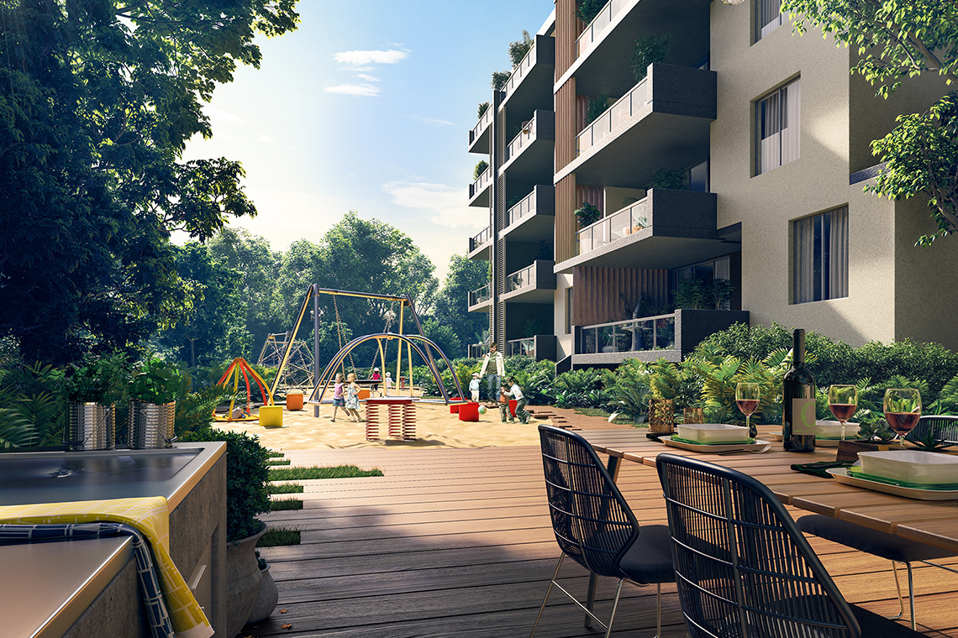
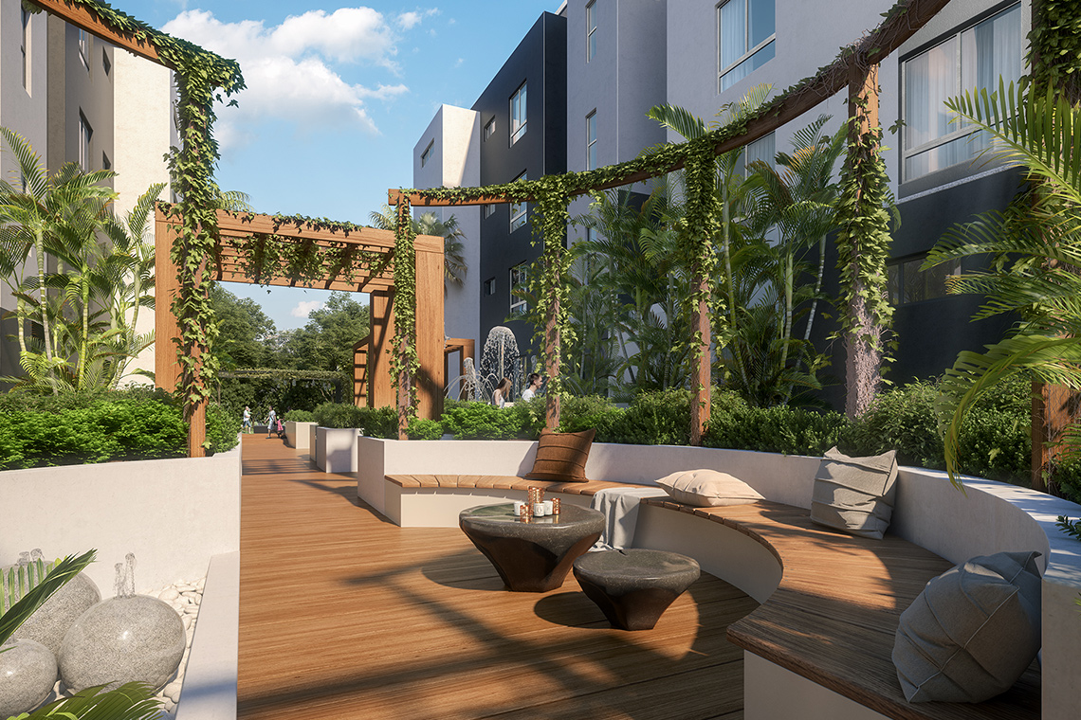

Wentworthville's most luxurious apartments.

Oasis presents bold, contemporary architecture in context with its historic surroundings.

Oasis presents bold, contemporary architecture in context with its historic surroundings.
Discover something truly special and find a unique sense of sanctuary at Oasis, where affordable luxury is within your reach. Uncover a Wentworthville you never knew, where exceptional architectural design and premium finishes combine with resort-style grounds to create an address quite unlike any other in the area.
Conceived with family living in mind, Oasis offers an array of superb facilities to make life a pleasure and inspire a feeling of community. Surrounded by magical gardens, you’ll feel a world away from the pace of urban life, yet with vibrant attractions and countless amenities only minutes from your door.
Discover something truly special and find a unique sense of sanctuary at Oasis, where affordable luxury is within your reach. Uncover a Wentworthville you never knew, where exceptional architectural design and premium finishes combine with resort-style grounds to create an address quite unlike any other in the area.
Conceived with family living in mind, Oasis offers an array of superb facilities to make life a pleasure and inspire a feeling of community. Surrounded by magical gardens, you’ll feel a world away from the pace of urban life, yet with vibrant attractions and countless amenities only minutes from your door.

Naturally Inspired Luxury

Light, spacious and stylish homes, with a choice of layouts to suit all lifestyles with high-end, modern designer finishes.

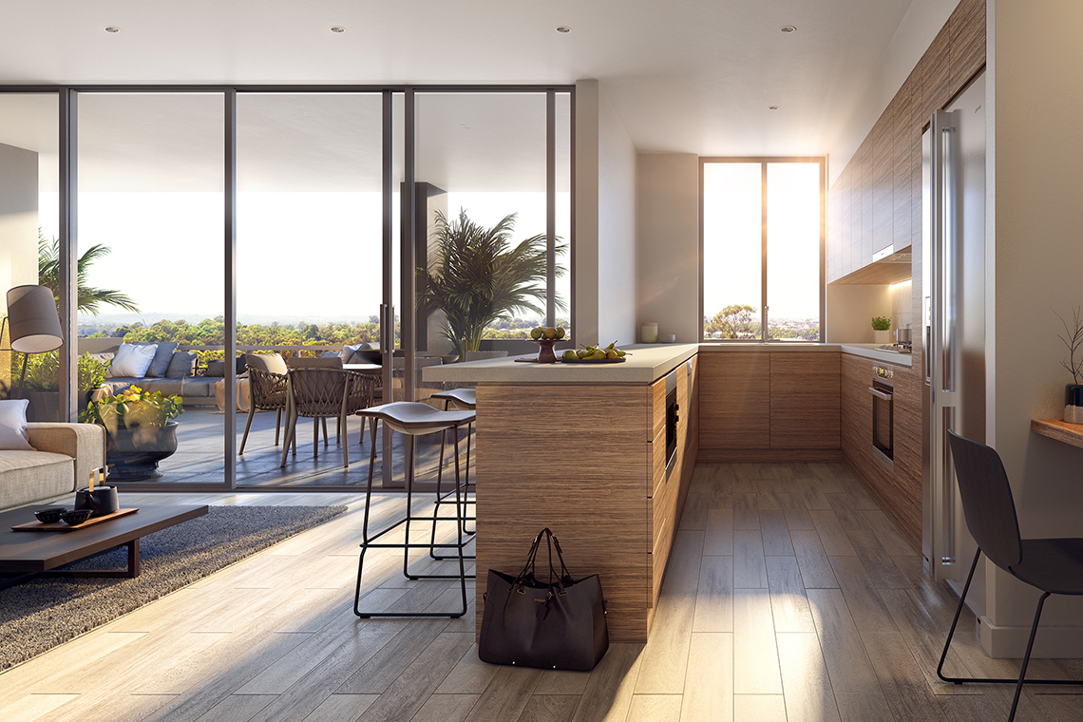
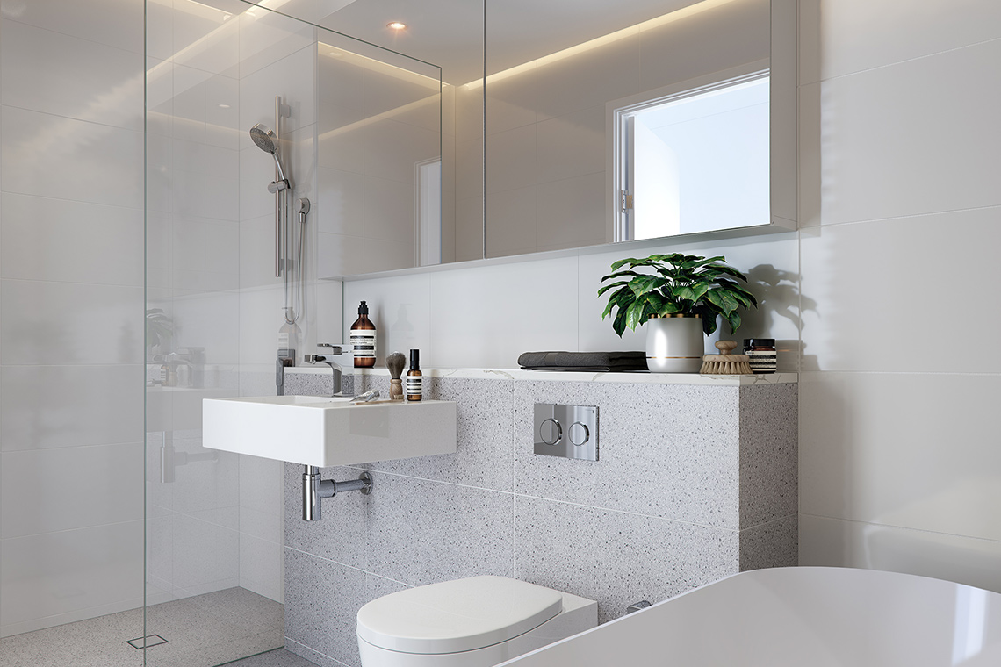
Offering a wide diversity of layouts to appeal to a broad demographic, Oasis is a collection of impeccably appointed 1, 2 and 3-bedroom apartments, some with media rooms and others with studies for versatility.
Its three architect-designed buildings are set amid beautifully landscaped grounds, achieving a more intimate, boutique feel within the larger context of the development. The clever design and positioning of the buildings is instrumental in optimising privacy, minimising noise and enhancing the feeling of tranquility. All apartments come with at least one security parking space along with private storage space.
Offering a wide diversity of layouts to appeal to a broad demographic, Oasis is a collection of impeccably appointed 1, 2 and 3-bedroom apartments, some with media rooms and others with studies for versatility.
Its three architect-designed buildings are set amid beautifully landscaped grounds, achieving a more intimate, boutique feel within the larger context of the development. The clever design and positioning of the buildings is instrumental in optimising privacy, minimising noise and enhancing the feeling of tranquility. All apartments come with at least one security parking space along with private storage space.

A Suburb Of Significance.

A Suburb Of Significance.

An area with increasing infrastructural investment, on the verge of exciting change.
View Google Map
Oasis is effortlessly convenient to everything you desire to make life easy and enjoyable, from public transport and educational facilities to recreational attractions, retail and entertainment. It’s a 400m walk to Wentworthville train station, with a journey to Parramatta taking just six minutes and Town Hall in the Sydney CBD taking 40 minutes, making commuting a breeze. Proximity to major arteries such as the M4 Motorway enhances accessibility to all reaches of Sydney. Neighbouring Parramatta, Sydney’s second largest CBD and a renowned centre of growth, caters to all of your shopping and entertainment desires.
The calibre of local schools, both private and public, reflects the area’s family oriented nature, while both the Parramatta and new Parramatta City campuses of Western Sydney University are just minutes away, with the newly opened Macquarie Street premises attracting an additional 10,000 students. Westmead Hospital is within a five minute drive, hence Wentworthville’s popularity with the medical profession.

View Google Map

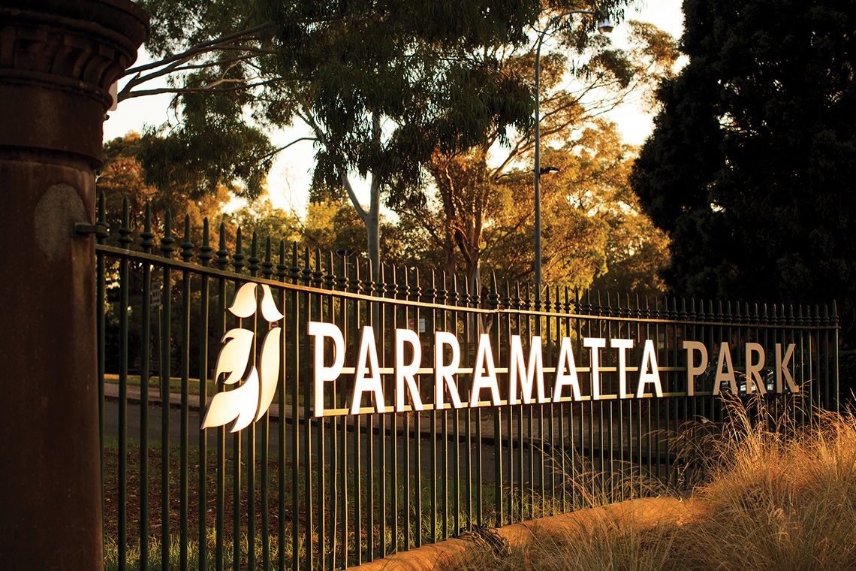

Culture, past and present.

The perfect balance of a quiet, friendly community and the convenient centrality of a city fringe home.
A sense of community is integral to Wentworthville life, even more so as the area welcomes new cultural attractions, culinary endeavours, festivals and enhanced public spaces. It is becoming an increasingly popular option for families seeking an affordable home on the Sydney central fringe, offering exceptional value for money and all the excitement and vibrancy of urban life.
Embracing its multiculturalism, the area has a growing local dining scene where you can sample authentic cuisine from around the globe. A hub of culture and entertainment, Parramatta is home to the much-loved Riverside Theatre and hosts renowned events such as Tropfest short film festival and Sydney Festival performances.

Conquest is a renowned Australian-owned property development group that has for the past decade built a reputation for exceeding expectations in development and construction. One of the core fundamental advantages of the company is the degree of knowledge and involvement during all phases of the development and construction process, which allows them to achieve an exceptionally high level of detail throughout every project.

Consisting of 25 Landscape Architects and holding offices in both Sydney and Melbourne, Site Image Landscape Architects has been establishing a reputation for landscaping excellence for over 25 years. Expertise spans all phases of landscape architectural project delivery, from masterplan, concept design and development through to documentation and construction supervision, with a particular focus on design excellence and sustainable environmental outcomes.

